Jess Clarke
j.clarke14@newcastle.ac.uk
https://research.ncl.ac.uk/biofouling/
https://orcid.org/0000-0002-7145-9367

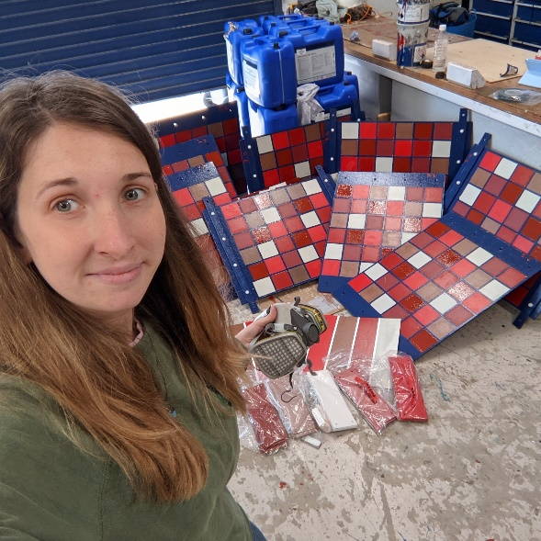
Project: Biofouling invertebrates and their larvae as vectors of antimicrobial resistance (AMR) and marine pathogens
Traditionally anti-fouling technology is based upon the use of biocides in paints to prevent colonization or to kill through toxicity of potential settlers. Consequently, only species that are ‘resistant’ are able to thrive on these surfaces. There is evidence that heavy metals and biocides in these paints, select for resistant species and bacteria within the biofilms that form, while also co-selecting those that demonstrate Antibiotic Resistance, cumulatively forming the ‘resist-ome’. Fouling communities may therefore pose as a reservoir of anti-microbial resistance (AMR) and pathogenic bacteria & viruses (e.g. Vibrio parahaemolyticus and Pseudomonas putrefaciens) within the marine environment.
AMR is recognised by the World Health Organization (WHO) as one of the most important global issues facing human and animal health. Climate change and other anthropogenic influences exacerbate the increased presence of AMR in the marine environment. Due to the heavy use of anti-foulants on ships that travel between different ecological regions, the risk of spread of potential AMR (and associated resist-ome) and pathogenic species is therefore of high concern and interest.

Research Questions

- Microbiome: Characterise the associated microbiomes of fouling invertebrates on different antifouling coatings.

- Pathogenic species: Analyse and quantify the presence of pathogens such as vibro within these microbiomes.

- AMR genes: Analyse and quantify the presence of resistance genes such as AMR genes within these microbiomes.

- Assess risk of spread of AMR genes and pathogens into the environment via invertebrate larvae as a vector.

Techniques

I will use various sequencing techniques, including 16s rRNA sequencing and shotgun sequencing to analyse the microbiome communities within fouling invertebrates on different anti-fouling paints. Using the bioinformatic data from shotgun sequencing and various available databases, I will identify key pathogenic species and resistance genes including antimicrobial resistance (AMR) genes within my samples.

Supervisors and Collaborators

- Nick Aldred, Essex University, UK
- Andy Nelson, Northumbria University, UK
- Tom Vance, Plymouth marine laboratory applications ltd. UK
- Tony Clare, Newcastle University, UK
- Jem Stach, Newcastle University, UK

Publications

- Schardt, L., Guajardo, A.M., Koc, J., Clarke, J.L., Finlay, J.A., Clare, A.S., Gardner, H., Swain, G.W., Hunsucker, K., Laschewsky, A., Rosenhahn, A. Low fouling polysulfobetaines with variable hydrophobic content. Macromolecular Rapid Communications. In Press. (2021)

- Barry, M. E., Davidson, E. C., Zhang, C., Patterson, A. L., Yu, B., Leonardi, A. K., Duzen, N., Malaviya, K., Clarke, J. L., Finlay, J. A., Clare, A. S., Chen, Z., Ober, C. K., & Segalman, R. A. (2019). The Role of Hydrogen Bonding in Peptoid-Based Marine Antifouling Coatings. Macromolecules, 52(3), 1287–1295. https://doi.org/10.1021/acs.macromol.8b02390

- Clarke, J. L., Davey, P. A., Aldred, N., & Aldred, N. (2020). Sea anemones (Exaiptasia pallida) use a secreted adhesive and complex pedal disc morphology for surface attachment. BMC Zoology, 5(1), 1–13. https://doi.org/10.1186/s40850-020-00054-6

- Davey, P. A., Power, A. M., Santos, R., Bertemes, P., Ladurner, P., Palmowski, P., Clarke, J., Flammang, P., Lengerer, B., Hennebert, E., Rothbächer, U., Pjeta, R., Wunderer, J., Zurovec, M., & Aldred, N. (2021). Omics-based molecular analyses of adhesion by aquatic invertebrates. Biological Reviews, 96(3), 1051–1075. https://doi.org/10.1111/brv.12691

- Davey, P. A., Rodrigues, M., Clarke, J. L., & Aldred, N. (2019). Transcriptional characterisation of the Exaiptasia pallida pedal disc. BMC Genomics, 20(581), 1–15.

- Koc, J., Schardt, L., Nolte, K., Beyer, C., Eckhard, T., Schwiderowski, P., Clarke, J. L., Finlay, J. A., Clare, A. S., Muhler, M., Laschewsky, A., & Rosenhahn, A. (2020). Effect of Dipole Orientation in Mixed, Charge-Equilibrated Self-assembled Monolayers on Protein Adsorption and Marine Biofouling. ACS Applied Materials and Interfaces, 12(45), 50953–50961. https://doi.org/10.1021/acsami.0c11580

- Koc, J., Schönemann, E., Amuthalingam, A., Clarke, J., Finlay, J. A., Clare, A. S., Laschewsky, A., & Rosenhahn, A. (2019). Low-Fouling Thin Hydrogel Coatings Made of Photo-Cross-Linked Polyzwitterions. Langmuir, 35(5), 1552–1562. https://doi.org/10.1021/acs.langmuir.8b02799

- Leonardi, A., Zhang, A. C., Düzen, N., Aldred, N., Finlay, J. A., Clarke, J. L., Clare, A. S., Segalman, R. A., & Ober, C. K. (2021). Amphiphilic Nitroxide-Bearing Siloxane-Based Block Copolymer Coatings for Enhanced Marine Fouling Release. ACS Applied Materials & Interfaces, 13(24), 28790–28801. https://doi.org/10.1021/acsami.1c05266

- Lo Giudice Cappelli, E., Clarke, J.L, Smeaton, C., Davidson, K., & Austin, W.E.N (2019). Organic-carbon-rich sediments: Benthic foraminifera as bio-indicators of depositional environments. Biogeosciences, 16(21), 4183–4199. https://doi.org/10.5194/bg-16-4183-2019

- Wanka, R., Aldred, N., Finlay, J. A., Amuthalingam, A., Clarke, J. L., Clare, A. S., & Rosenhahn, A. (2019). Antifouling Properties of Dendritic Polyglycerols against Marine Macrofouling Organisms. Langmuir, 35(50), 16568–16575. https://doi.org/10.1021/acs.langmuir.9b02720

- Wanka, R., Koc, J., Clarke, J., Hunsucker, K. Z., Swain, G. W., Aldred, N., Finlay, J. A., Clare, A. S., & Rosenhahn, A. (2020). Sol-Gel-Based Hybrid Materials as Antifouling and Fouling-Release Coatings for Marine Applications. ACS Applied Materials and Interfaces, 12(47), 53286–53296. https://doi.org/10.1021/acsami.0c15288

- Yu, W., Koc, J., Finlay, J. A., Clarke, J. L., Clare, A. S., & Rosenhahn, A. (2019). Layer-by-layer constructed hyaluronic acid/chitosan multilayers as antifouling and fouling-release coatings. Biointerphases, 14(5), 051002. https://doi.org/10.1116/1.5110887

- Yu, W., Wanka, R., Finlay, J. A., Clarke, J. L., Clare, A. S., & Rosenhahn, A. (2020). Degradable hyaluronic acid/chitosan polyelectrolyte multilayers with marine fouling-release properties. Biofouling, 36(9), 1049–1064. https://doi.org/10.1080/08927014.2020.1846725

Other publications
- Clarke, J., & Stern, R. (2015). Detecting Pseudo-nitzschia and Alexandrium spp. from archival CPR samples using molecular techniques. In SAHFOS 2015 Annual report

- Stern, R, Martins, C., Walker, C., Clarke, J., Tarran, G., & Edwards, M. (2015). Maximising autonomous marine observations using the Continuous Plankton Recorder survey: a DEFRA technical report.
- Stern, Rowena, Helaouet, P., & Clarke, J. (2015). HAB genera identified on archival samples from the continuous plankton recorder survey. Harmful Alage News, 52, 2,7. https://doi.org/10.1007/s00192-014-2608-2

